Apology & Gender Fall 2020 - U07

Start of Block: Instruction

Q1 PURPOSE OF THE STUDY
The purpose of this study is to investigate social media apologies and their effect on how people feel about it.
NUMBER OF STUDY PARTICIPANTS
If you decide to be in this study, you will be one of about 200 people in this research study.
DURATION OF THE STUDY
Your participation will involve a maximum of 10 minutes to complete the questionnaire.
PROCEDURES
If you agree to be in the study, we will ask you to do the following:
1. Look over the Twitter Post presented. 2. Answer a few follow-up questions regarding how you feel about the profile owner's behavior or the owner himself.
RISKS AND/OR DISCOMFORTS
The study has the following possible risks to you: Minor discomfort with personal questions regarding how you would respond to specific scenarios in social media.
BENEFITS
The study has the following possible benefits to you: Your participation in the study will provide useful data for the development of the study. Accordingly, the findings of our study will contribute to the advancement of knowledge in the field of Psychology.
Do you consent to participate in this research project?
- Yes (1)
- No (2)

Skip To: End of Survey If PURPOSE OF THE STUDY The purpose of this study is to investigate social media apologies and the... = No
End of Block: Instruction

Start of Block: Instruction

Q2 On the next page, you will see a social media page for a Twitter user named Charlie Webb. Carefully read EVERYTHING on it, as we will ask you about your impressions later in this survey.

End of Block: Instruction

Start of Block: I&F

I&F
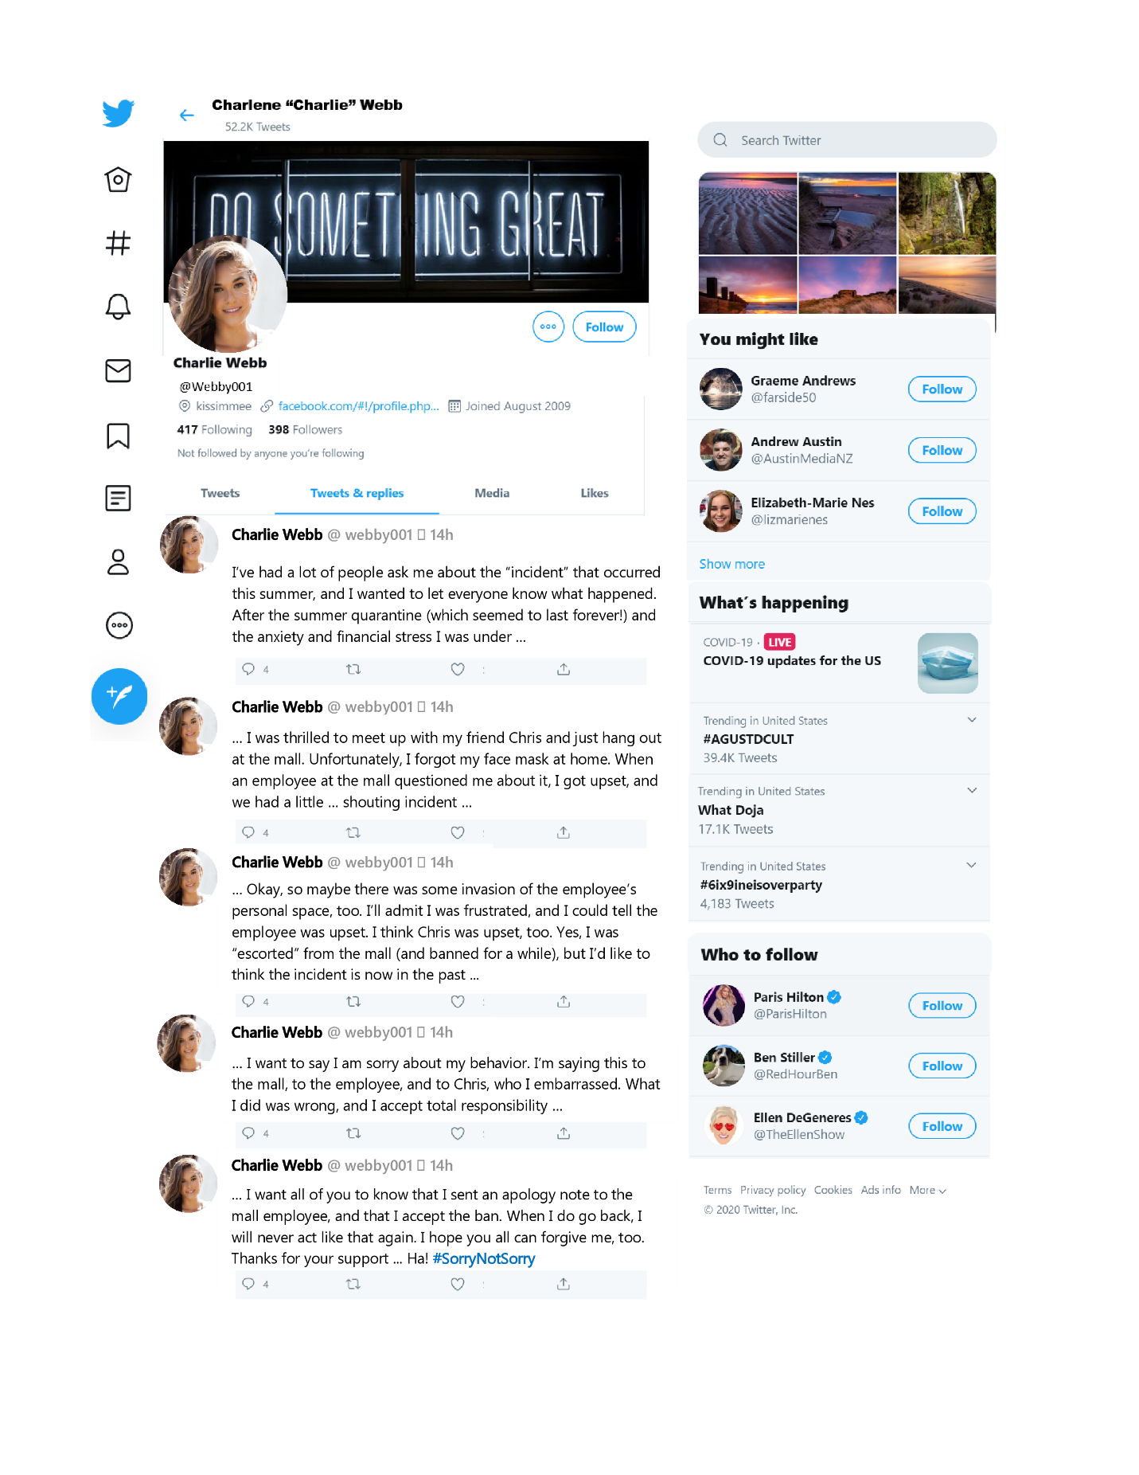

I&F Read: Did you fully read the Twitter post above?
- Yes (5)
- No--please read (6)

End of Block: I&F

Start of Block: I&M

I&M
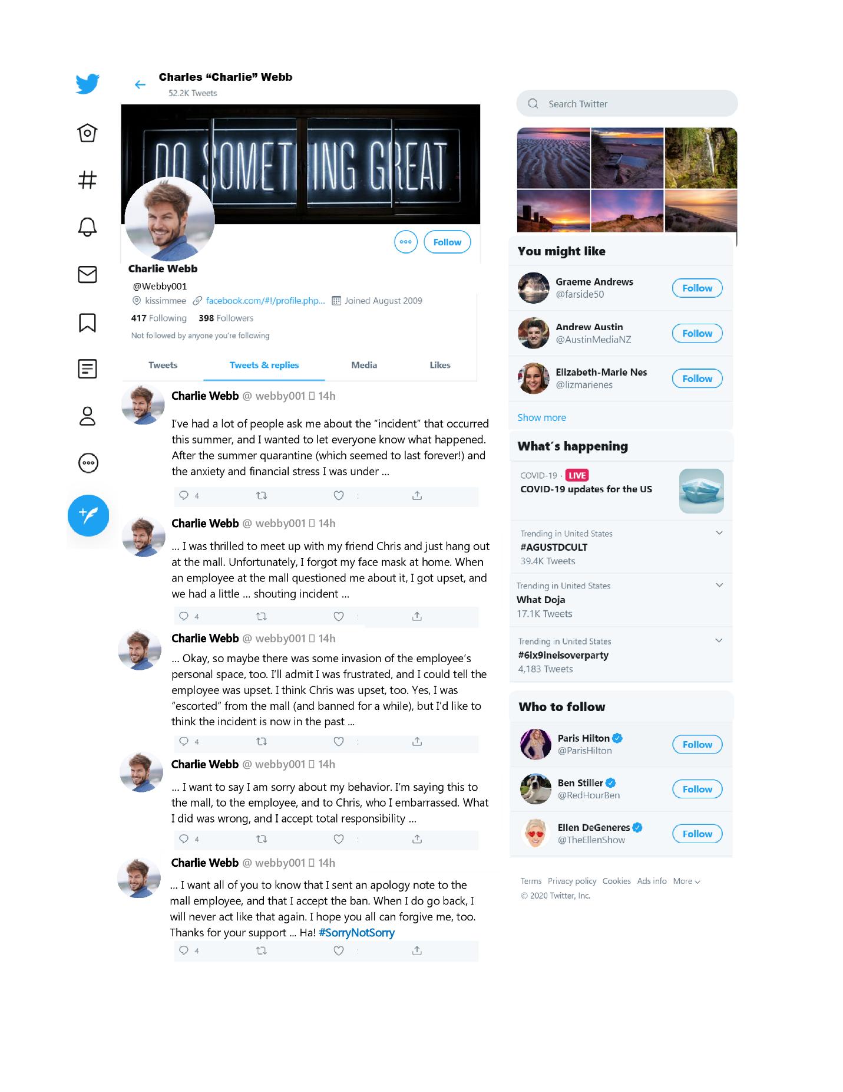

I&M Read: Did you fully read the Twitter post above?
- Yes (5)
- No--please read (6)

End of Block: I&M

Start of Block: S&F

S&F
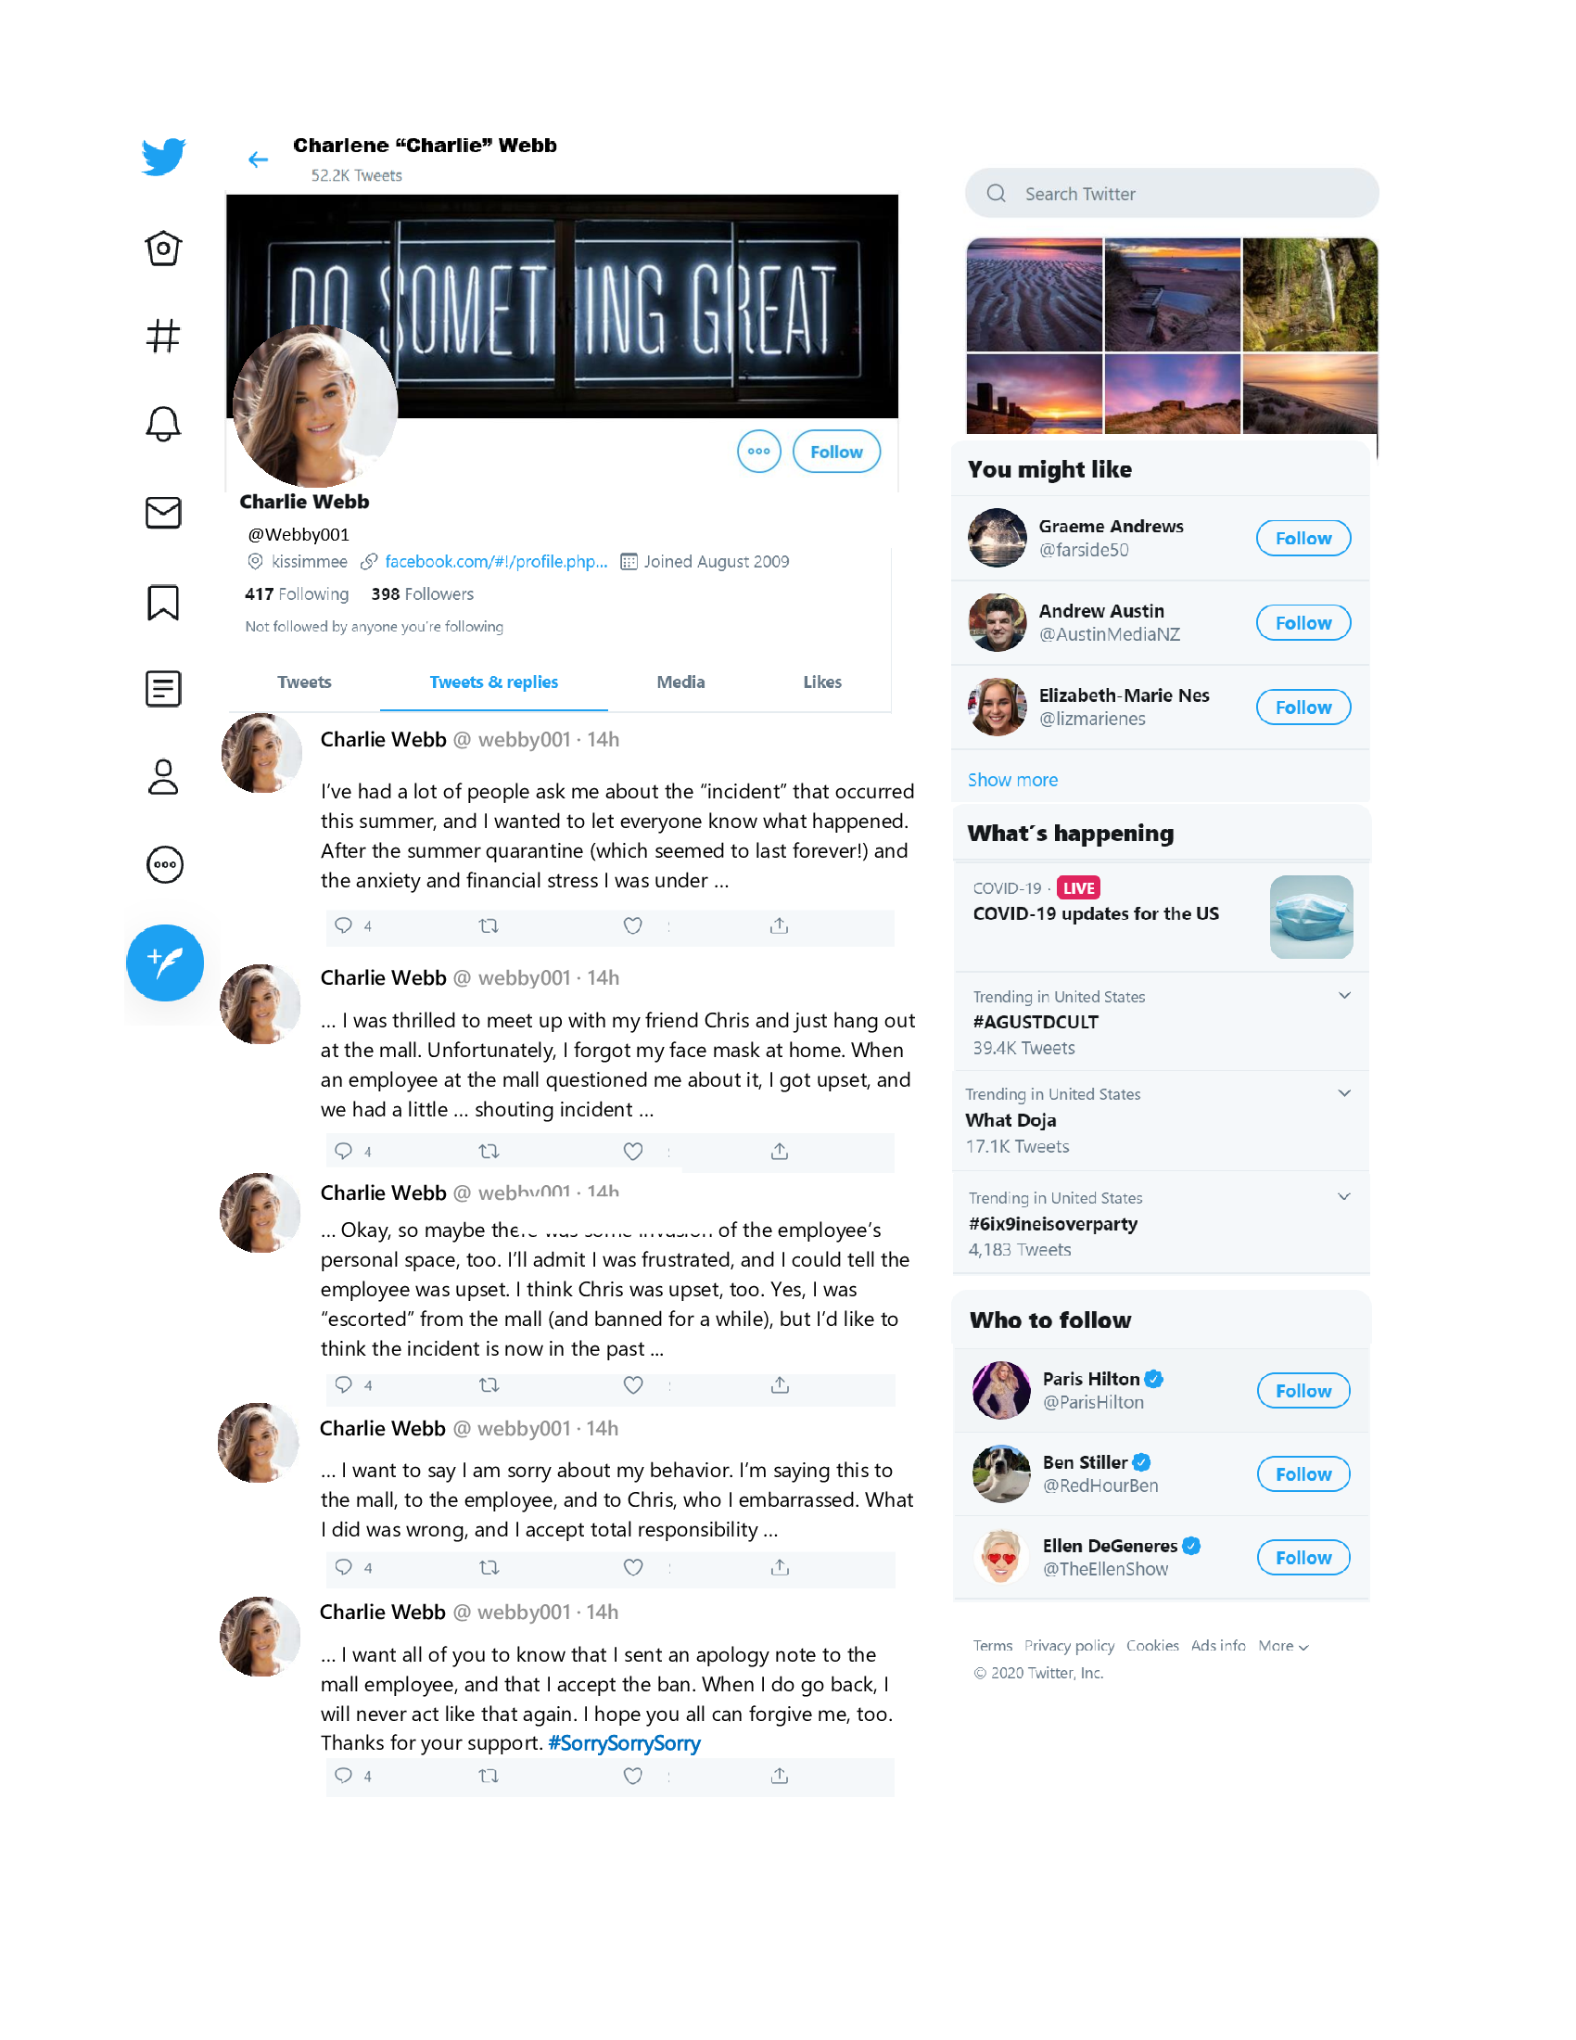

S&F Read: Did you fully read the Twitter post above?
- Yes (5)
- No--please read (6)

End of Block: S&F

Start of Block: S&M

S&M
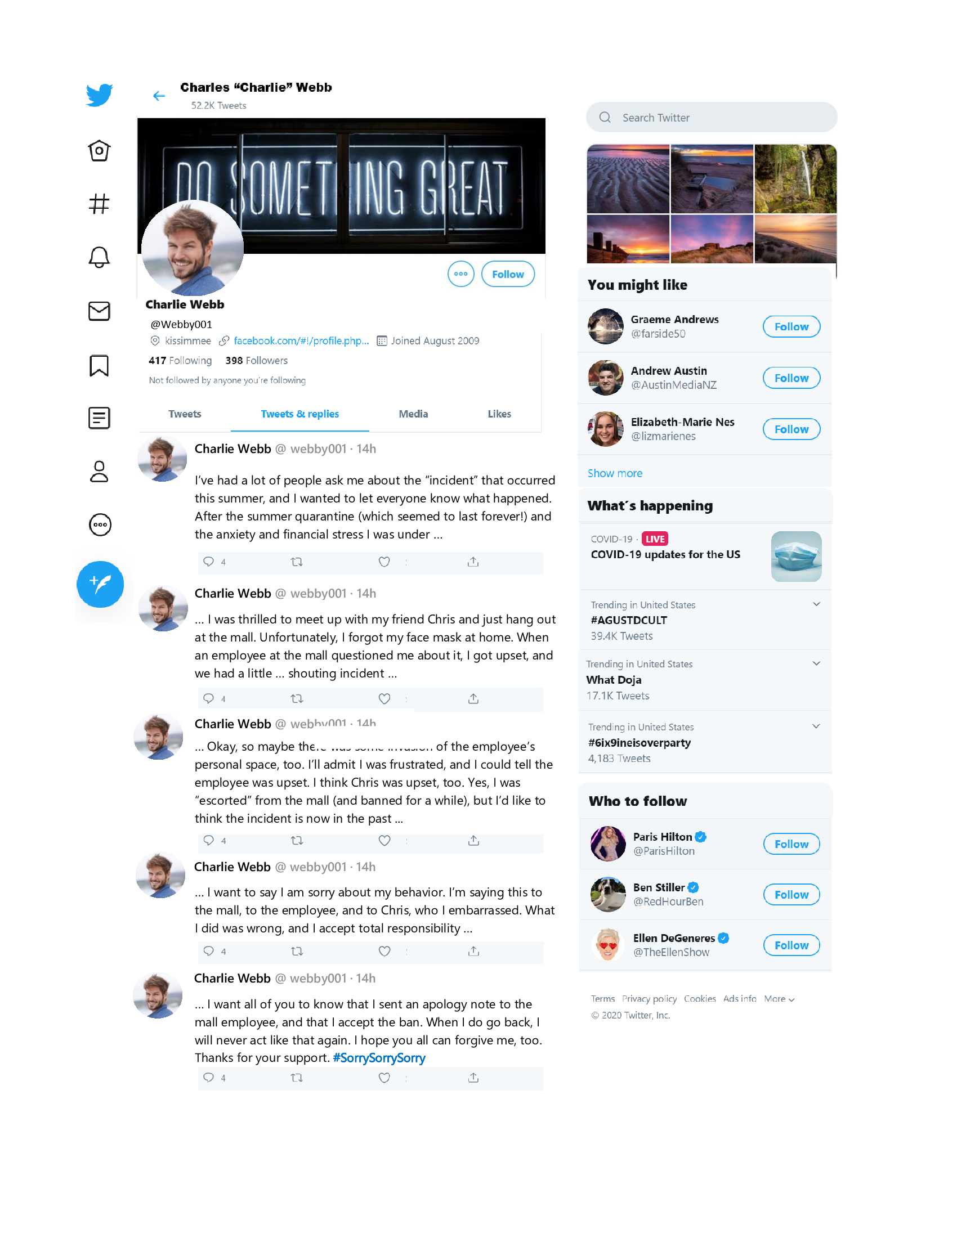

S&M Read: Did you fully read the Twitter post above?
- Yes (5)
- No--please read (6)

End of Block: S&M

Start of Block: Apology's Survey

Part Two: Scale Without looking back, rate your impressions of Charlie Webb's apology on Twitter.
 | Strongly disagree (1) | Disagree (2) | Somewhat disagree (3) | Somewhat agree (4) | Agree (5) | Strongly Agree (6)
Charlie's apology acknowledged the behavior was wrong. (1)
Charlie's apology showed an acceptance of responsibility. (2)
Charlie's apology showed an expression of remorse. (3)
Charlie's apology included an offer to pay back (compensate) for the behavior. (4)
Charlie's apology involved a pledge not to engage in the behavior again. (5)
Charlie's apology seemed forced. (6)
Charlie's apology seemed sincere. (7)
I would accept Charlie's apology. (8)
I think Charlie intended to forget the face mask. (9)

End of Block: Apology's Survey

Start of Block: Charlie's survey

Part Three: Without looking back, rate your feelings about both Charlie and Charlie's behavior.
 | Strongly disagree (1) | Disagree (2) | Somewhat disagree (3) | Somewhat agree (4) | Agree (5) | Strongly Agree (6)
I think Charlie's behavior was wrong. (1)
I think Charlie's behavior was understandable. (2)
I think Charlie's behavior was forgivable. (3)
Charlie seems regretful. (4)
Charlie seems selfish. (5)
Charlie seems moral. (6)
Charlie seems rude (7)
I don't think people should be forced to wear a mask at stores if they don't want to wear it. (8)

End of Block: Charlie's survey

Start of Block: Demographic Information

Part Four: Please provide the following demographic information. Note: You can leave blank any questions you feel uncomfortable answering.

Gender What is your gender?
- Male (1)
- Female (2)
- Other (3)

Age What is your age?
________________________________________________________________

Race What is your race/ethnicity?
- Caucasian (1)
- Hispanic (2)
- Native Indian (3)
- African American (4)
- Asian American (5)
- Others--Please specify (6) ________________________________________________

Language Is English your first language?
- Yes (1)
- No (2)
- If no, specify your first language (3) ________________________________________________

FIU Are you a student at Florida International University?
- Yes (1)
- No (2)

Relationship What is your relationship status?
- Single / No Relationship (1)
- In a relationship (2)

End of Block: Demographic Information

Start of Block: Manipulation Check

Part Five: Without looking back, what hashtag did Charlie end the Twitter post with?
- #SorrySorrySorry (1)
- #SorryNotSorry (3)
- Unknown (4)

Part Five: Without looking back, was Charlie male or female?
- Male (2)
- Female (3)
- Unknown (4)

End of Block: Manipulation Check

Start of Block: Debriefing

Debriefing Thank you for participating in our experiment! We appreciate the time you took to complete this survey and for helping us test our hypothesis.
Our experiment contained two independent variables we were observing. The purpose of the first independent variable is to determine if the type of apology influences how people feel about it. There are two conditions: In one condition, Charlie gave a sincere apology. In other condition, Charlie seemed to give a sincere apology, but at the end provided the sarcastic hashtag #SorryNotSorry, making the apology seem rather insincere. We expect that people will view the sincere apology more favorably than the insincere apology.

The second independent variable of the experiment looks at whether Charlie is male or female. That is, some participants saw a female Charlie ("Charlene") giving either a sincere or insincere apology while other participants saw a male Charlie ("Charles") giving either a sincere or insincere apology.

To test this how participants respond to both the sincerity of the apology and the gender of the person who apologized, our participants responded to a set of scaled questions that asked them to rate the fictional Twitter user's post.
Our hypotheses are as followed: In general, participants in the sincere apology condition will view the apology more favorably than participants in the insincere apology condition. We predict that participants will rate the female Charlie more favorably than the male Charlie. Finally, we predict that participants will find Charlie’s apology most acceptable in the sincere and female condition and least acceptable in the insincere and male condition, with participants in the sincere and male condition and participants in the insincere and female conditions falling between those extremes.

If you have any questions about the purpose, procedures, or any other issues relating to this research study you may contact Dr. Winter at winterry@fiu.edu. If you would like to talk with someone about your rights of being a subject in this research study or about ethical issues with this research study, you may contact the FIU Office of Research Integrity by phone at 305-348-2494 or by email at ori@fiu.edu. Thank you again for your participation in our experiment!

Name Please provide the full name of the student who referred you this survey so that we can grant them credit (provide their LAST then FIRST name separated by a comma). Please spell their name correctly, as they will not get credit for their assignment otherwise.
________________________________________________________________

End of Block: Debriefing

